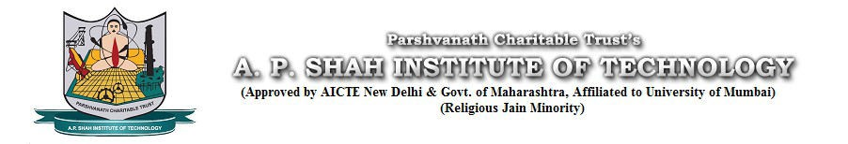

Department of Information Technology

Semester: V Name of Student:
Academic Year: 2022-23 Student ID:
Class / Branch: TE IT
Subject: Security Lab (SL)
Name of Instructor: Prof. Apeksha Mohite

EXPERIMENT NO. 10
Aim: To study and test message integrity by using MD-5, SHA-1 for varying message sizes
- Original File in MD5 hash

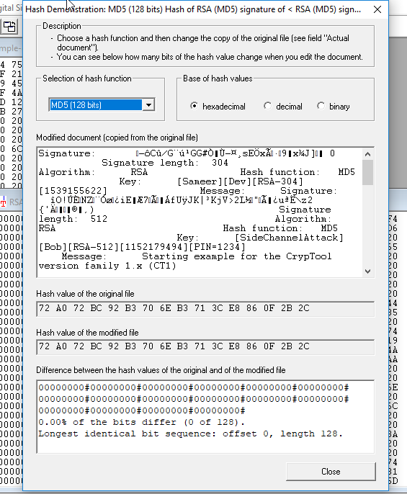
- % change in differing bits of MD5

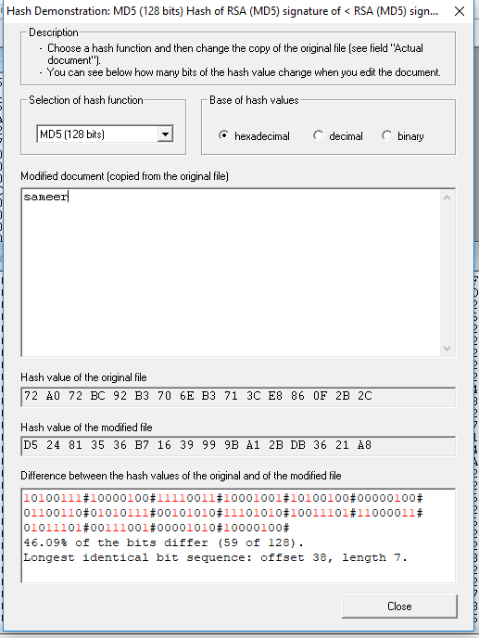
- Original File in SHA-1 hash

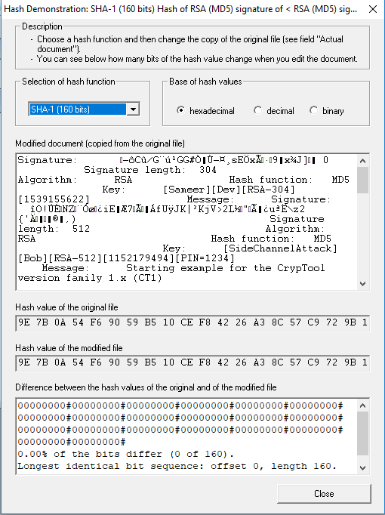
- % change in differing bits of SHA-1

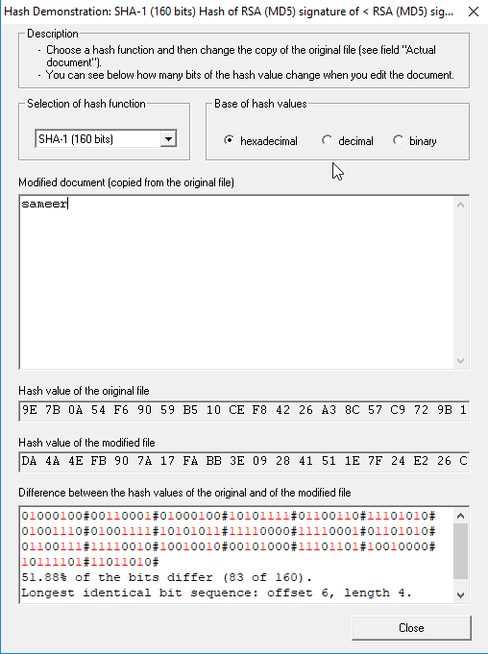

md5sum :

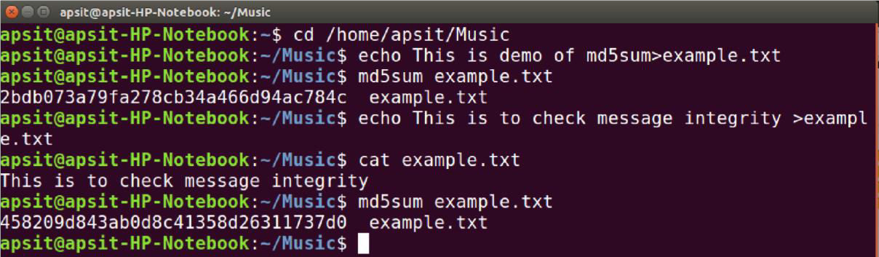

sha1sum: sha256sum/sha224sum/sha512sum/sha384sum :

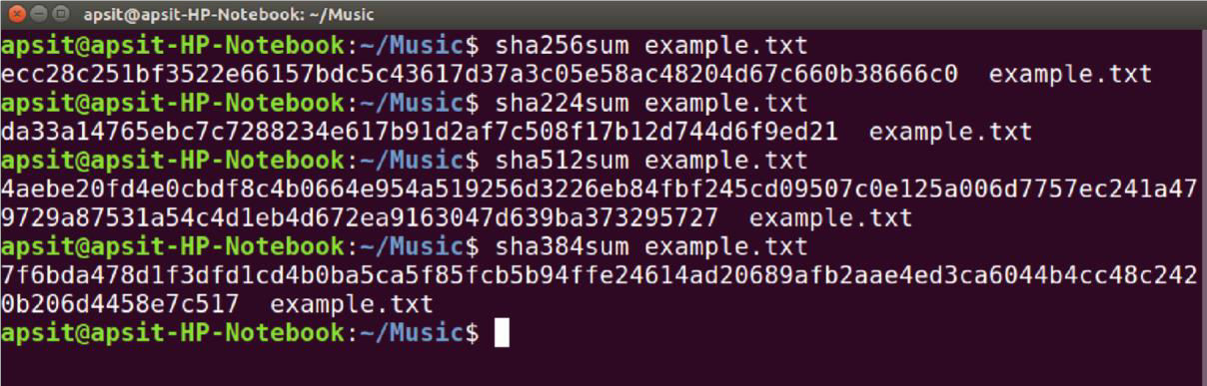

checking integrity of downloaded iso :

